**Dating App**

**Project Repository**

<https://github.com/munaja/deals-yc-w22>

**Requirement:**Please make sure the following programs are already installed in the computer:

* Programming Language: **Go** version **1.22.1**
* Database: **MariaDB** version **10.10**
* Memory Storage: **Redis** (use docker for windows user)

**Technical Infrastructure**

Used stacks:

* Programming Language: **Go** version **1.22.1**Reason: performant,
* Database: **MariaDB** version **10.10**   
  Reason: Light, scalable.
* Memory Storage: **Redis**  
  Reason: light, performant, relatively easy to use
* Project Layout: Golang Standard Project (https://github.com/golang-standards/project-layout)  
  Reason: relatively more organized.

**ERD**

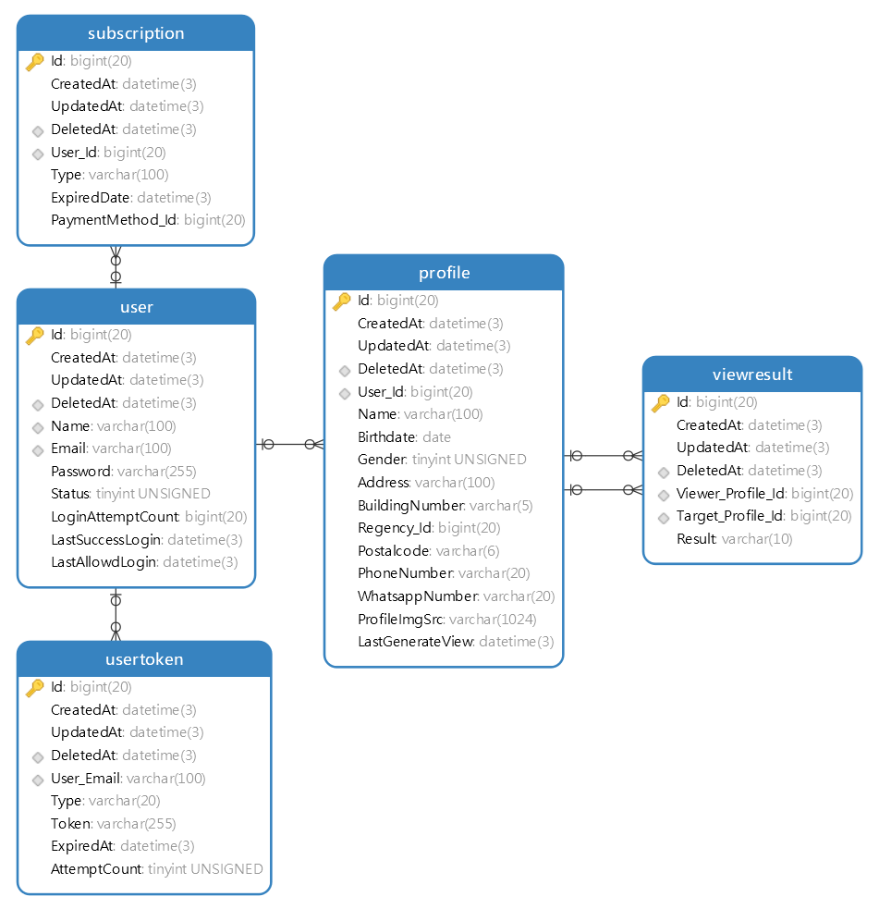

**Sequence Diagram**

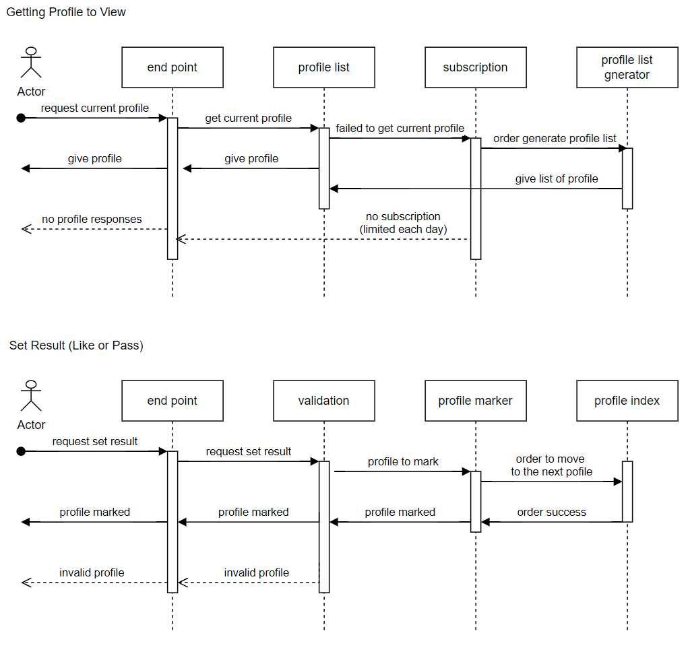

**Test Case**

1. User with without subscription will be limited to mark (pass or like) 10 profiles each days with the following steps:
2. Register user
3. Verify the account
4. Login
5. Visit enpoint “/view” to get the profile
6. Visit enpoint “/view-result” to mark the account
7. Repeat step e to f until reach the daily limit (10 marks per day)
8. User with with subscription can do unlimited mark profiles each day
9. Register user
10. Verify the account
11. Login
12. Visit enpoint “/view” to get the profile
13. Visit enpoint “/view-result” to mark the account
14. Repeat step e to f until exceeds the limit (10 marks per day)